Forms in HTML

HTML provide following tag for form creation.

<form>

<fieldset>

<legend>

<input>

<select>

<option>

<optgroup>

<textarea>

Using these tag we can create any types of web form.

Like registration form,Login form,contact form ….etc.

Coding of Form Creation

==================================

<body>

<form>

<fieldset>

<legend align="left">RegForm</legend>

<table>

<tr><td>Name</td>

<td><input type="text" placeholder="Enter Name Here"

required="required" name="na"></td></tr>

<tr><td>Password</td>

<td><input type="password" placeholder="Enter password Here"

required="required" name="p1" ></td></tr>

<tr><td>RePassword</td>

<td><input type="password" placeholder="Enter Repassword Here"

required="required" name="p2" ></td></tr>

<tr><td>Email</td>

<td><input type="email" placeholder="Enter Email Here"

required="required" name="e1" ></td></tr>

<tr><td>Date</td>

<td><input type="date" name="d1" ></td></tr>

<tr><td>PhoneNo</td>

<td><input type="number" name="ph1" ></td></tr>

<tr><td>SelectFile</td>

<td><input type="file" name="F1" required></td></tr>

<tr><td>Gender</td>

<td><input type="radio" name="r1" checked value="male" >Male

<input type="radio" name="r1" value="Female" >FeMale

</td></tr>

<tr><td>Language</td>

<td><input type="checkbox" checked name="c1" value="Hindi" >Hindi

<input type="checkbox" name="c2" value="English" >English

</td></tr>

<tr><td>course</td>

<td><select name="s1">

<optgroup label="Btech">

<option value="CS">CS</option>

<option value="EE">ee</option>

<option value="ME">Me</option>

</optgroup>

<optgroup label="MBA">

<option value="finance">Finance</option>

<option value="Hr">Hr</option>

</optgroup>

</select>

</td>

</tr>

<tr>

<td>Comment</td>

<td><textarea rows="7" cols="20" name="CM"></textarea>

</td>

</tr>

<tr>

<td><input type="submit" value="RegisterNow"></td>

<td><input type="reset" value="Refresh" ></td></tr>

</table>

</fieldset>

</form>

</body>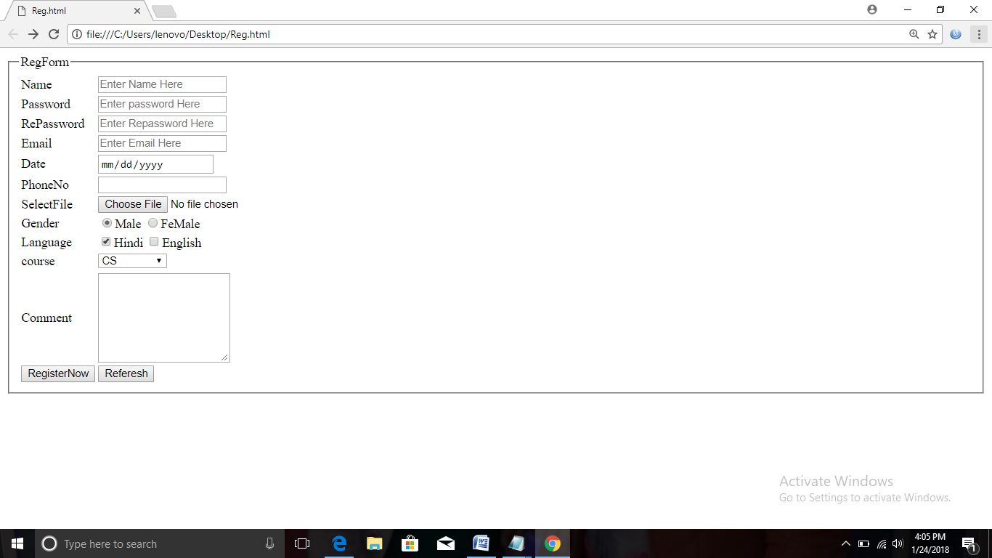

Comment in HTML

HTML comment start with <!- -

And end with - ->

All thing that are written inside the comment can not render(display) in output.

Example

<body>

<!- - body Section here - ->

<h1>Delhi Public School </h1>

<p>Para here </p>

</body>

Note:- Heading can not displayed in output.

HTML character entities

They are used to display special symbol on web page.

All HTML character entities start with ampersand(&) sign and end with semicolon (;)

&reg;

&copy;

&frac14;

&euro;

&pound;

&yen;

&nbsp;

&lt;

&gt;

To display heading tag on browser

&lt;H1&gt; dps &lt;/H1&gt;

o/p

<H1>dps </H1>